CUBIES Game Concept

- How to Play the Game:

Given a randomized cube pattern and a set of cubes to be eliminated, your objective is to eliminate a number of similar cube patterns. If you accidentally or intentionally hit your cube pattern in a different cube pattern, then your cube pattern will become part of the cubes to be eliminated. You have the freedom to hit your cube in the Sky Platform in order to eliminate consecutive similar cubes arranged in a column. You also have the option to use a Super Cube to eliminate a number of different cubes arranged in a row or in a column. In order for you to progress through the game, you must successfully eliminate all cubes before the time runs out. Otherwise, it will mean Game Over. The final score you earn in a level is determined by 3 factors namely: the current score you earn, the number of Super Cubes left, and the remaining time.

- Technical Details of the Game:

In the J2ME Wireless Toolkit emulator, it has a Screen Size of 300 pixels X 240 pixels. The size of the Cubes and Sky Platform are both 15 pixels X 15 pixels. And the maximum number of cubes in a row and In a column are 13 and 16 respectively.
- Cube Designs

Cubes are essential in playing this mobile game since they are all to be eliminated in order to progress through each level. Below are the different Cube Designs that are present in the entire gameplay.

This is the Super Cube which can be optionally use by the player to eliminate a series of different cubes in a row or in a column. Since the number of Super Cubes is limited, then use this Super Cube very wisely.


This is the Red Cube which has a symbol of a Heart. This is one of the 4 cubes that are present in all levels and difficulties.

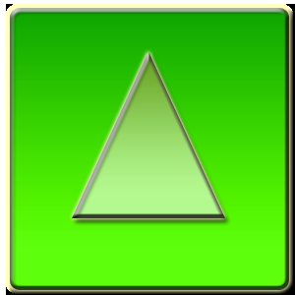
This is the Green Cube which has a symbol of a Triangle. This is one of the 4 cubes that are present in all levels and difficulties.


This is the Blue Cube which has a symbol of a Crescent. This is one of the 4 cubes that are present in all levels and difficulties.


This is the Yellow Cube which has a symbol of a Star. This is one of the 4 cubes that are present in all levels and difficulties.


This is the Pink Cube which has a symbol of a Square. This cube debuts in Level 3 and 2 of the CUBIES Normal and Hard Mode respectively.


This is the Orange Cube which has a symbol of a Circle. This cube debuts in Level 5 and 3 of the CUBIES Normal and Hard Mode respectively.

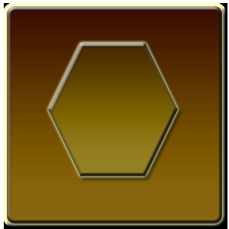
This is the Brown Cube which has a symbol of a Hexagon. This cube debuts in Level 4 of the CUBIES Hard Mode.

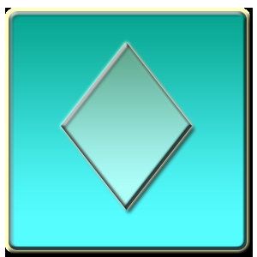
This is the Cyan Cube which has a symbol of a Diamond. This cube appears only once at Level 5 of the CUBIES Hard Mode.

- Level Dimensions in All Difficulty

You can play this mobile game depending on the difficulty you set: Easy, Normal, or Hard. The gameplay is divided into 5 levels in all difficulties. The table below shows the Number of Super Cubes and the Dimensions in each Level of Difficulty.

Difficulty | No. of Super Cubes | Level 1 | Level 2 | Level 3 | Level 4 | Level 5
Easy | 5 | 4 X 4 | 5 X 4 | 6 X 4 | 7 X 4 | 8 X 4
Normal | 3 | 4 x 4 | 5 x 4 | 6 x 5 | 7 x 5 | 8 x 6
Hard | 2 | 4 x 4 | 5 x 5 | 6 x 6 | 7 x 7 | 8 x 8

- Sky Platform Patterns

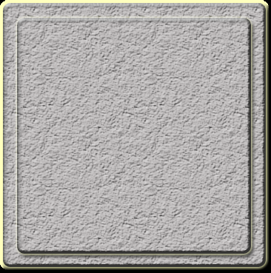
This is the Sky Platform which can be use to either eliminate a series of similar cubes in a column or add a cube on top of a different cube. Use this platform to your own advantage.

- CUBIES Game Demonstration:

This is a sample schematic game environment of CUBIES. It contains a Sky Platform pattern, a randomized 16 cube patterns, and a randomized Base Cube, which is initially located at the bottom, for the player to use.

Score = 00000 Super Cube = 5 Time = 3:54

Assuming that a Green Base Cube appears, you must move up once and hit it with the matching cube patterns.

Score = 00090 Super Cube = 5 Time = 3:49

Based on the previous step, assuming that you eliminated 3 Green cube patterns for 3 seconds in 3:51, then Score = 3² X 10 = 90. Now, the 3 Yellow and 3 Red Cube patterns directly above the eliminated Green Cubes are all moved down by one column. And another randomized Base Cube appears, this time a Yellow one. Then you either have the option to hit the corresponding Yellow Cube either in the 1st column which has only one or in the 11th row which has 3 consecutive cubes. Of course, you want to target the 11th row, so move up once and hit the 11th row.

Score = 00180 Super Cube = 5 Time = 3:44

Based on the previous step, assume once again that you eliminated 3 Yellow cube patterns for 3 seconds in 3:46, then Score = 3² X 10 = 90. Now, add your current score to your previous score, you will now earn a Score of 180. A Blue Base Cube which randomly appears and you want to hit the 4 similar cube patterns in the 13th row. You must move down twice and hit the target.

Score = 00340 Super Cube = 5 Time = 3:40

Based on the previous step, you eliminated 4 Blue cube patterns for 3 seconds in 3:41, then Score = 4² X 10 = 160. Once again, add your current score to your previous score and you will earn a Score of 340. A Red Base Cube randomly appears and you will also hit 4 similar cube patterns. You can directly hit the target without moving since your Base Cube is aligning with the target.

Score = 00500 Super Cube = 5 Time = 3:30

Based on the previous step, you eliminated 4 Red cube patterns for 3 seconds in 3:37, then Score = 4² X 100 = 160. Again, add your current score to your previous score and you will earn a Score of 5000. In this phase, only 1 of the cube patterns either Yellow or Red will be your Base Cube. In either case, you can change your Base Cube to a Super Cube pattern, which is represented by a Gray Cube, in order to eliminate a row or a column of different cubes. Since our target is the Yellow and Red Cubes arranged in a column, then move up twice and hit the target

Score = 00500 Super Cube = 4 Time = 3:26

Based on the previous step, you eliminated 2 different cube patterns. As you will notice, your Score did not increase. This is because the use of a Super Cube eliminates a series of cubes in a row or column regardless whether they are similar or not. By eliminating all cubes before the time runs out, you basically will advance to the next level and repeat the routine.

Score = 04560 Super Cube = 4 Time = 0:00

In the final step, the remaining time is computed by Remaining Time = ((3 X 60) + 26) X 10 = 2060. To get the Final Score you earn in the level, you simply add your Previous Score, the Number of Super Cubes left worth 500 points each and the Remaining Time. You get a Total Score of 4560. This ends the CUBIES Game Demonstration.

